Student name: Trịnh Minh Trí

Student ID: 20146288

Class: Artificial Intelligence - 01CLC

1. **There are different interpretations of artificial intelligence in different contexts. Please elaborate on the artificial intelligence in your eyes.**

For me, artificial intelligence or AI, is the intelligence that exhibited by machines. This intelligence is not real. AI mimics cognitive functions exhibited by human such as problem-solving or learning, in order to help machines to work more effectively.

1. **Artificial intelligence, machine learning and deep learning are three concepts often mentioned together. What is the relationship between them? What are the similarities and differences between the three terms?**

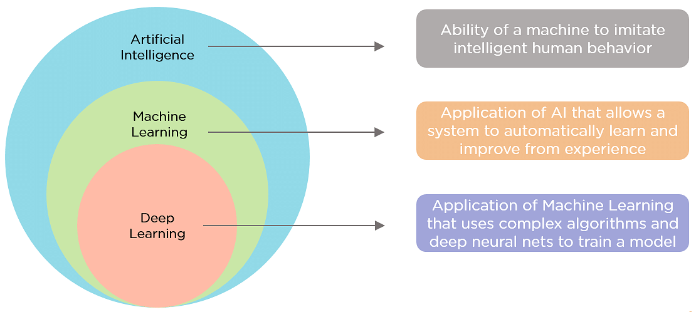

Fig 1: Relationship between artificial intelligence, machine learning, and deep learning

Differences between the three terms:

- Artificial Intelligence: a program that can sense, reason, act and adapt.

- Machine learning: algorithms whose performance improve as they are exposed to more data over time.

- Deep learning: subset of machine learning in which multilayered neural networks learn from vast amounts of data.

1. **After reading the artificial intelligence application scenarios in this chapter, please describe in detail a field of AI application and its scenarios in real life based on your own life experience.**

One of the application of AI is content recommendation. Various platforms that we use in our daily lives like e-commerce, entertainment websites, social media, video sharing platforms, like Youtube, etc., all use the recommendation system to get user data and provide customized recommendations to users to increase engagement. For example, when you search videos about cats on Youtube, the platform will recommend a lot of videos about this topics. In the next time when you use Youtube, some video about cats will appear on your window.

1. **Which chip is for deep neural networks and Ascend AI processors. Please brief these four major modules.**

- CPU: ARM A-9, HUAWEI Ascend 310, HUAWEI Ascend 910,…

- GPU: NVDA

- ASIC: Intel eASIC N5X, Intel eASIC N3XS,…

- FPGA: FPGA Intel,…

1. **Based on your current knowledge and understanding, please elaborate on the development trends of artificial intelligence in the future in your view.**

In my view, some of the development trends of artificial intelligence in the future are cyber security, healthcare, manufacturing,…